Classroom Management Plan
Bailey Barnes
University of Mary
Introduction
Having good classroom management strategies are the key to being an effective teacher. Although there are many different ideas on what successful classroom management looks like, the three authors, Fay, Marzano, and Wong all have strategies that I would like to implement in my classroom. Fay, in Love & Logic, believes in giving students choices. Marzano is concerned with engaging the classroom, and Wong is most concerned with teaching procedures and having bell work. I want to integrate all of these strategies into my classroom management plan in order to be an effective teacher.

The First Day of School
When it comes to the first day of school classroom management, I like Harry Wong’s ideas. The first thing that I will do on the first day of class is immediately teach procedures. Wong’s book, The Classroom Management Book is a great resource because it gives procedures for almost every single situation. I like Wong’s High School First-Week Plan because it is a clear guide to which procedures should be taught at which time. (See Appendix A). I want my classroom to be extremely well managed, and Wong’s philosophy is not only thorough, but is extremely organized, which is something I appreciate. I also want to introduce the classroom rules in a funny, lighthearted manner. Marzano writes that, “A teacher’s positive demeanor is also communicated by using humor” (p. 6). I will introduce the classroom rules by showing them funny pictures and videos of what NOT to do, or introduce funny memes to show them proper or improper behavior. This will also keep students engaged in their learning because not only is humor being used, but the students are enjoying the content that is being taught.
Classroom Rules
Similar to Marzano’s ideal rules in a secondary classroom, I think there should be very few rules that cover a broad spectrum of behavior. Marzano writes, “Rules and procedures typically fall into several categories, including general expectations for behavior, beginning and ending of the day or the period, transitions and interruptions, materials and equipments, groups work, and teacher-led activities” (p. 26). Making just one or two rules that cover each of these categories will ensure for a small but effective list of proper classroom behavior. To teach and enforce these rules, I plan to use Wong’s procedures for each of these individual areas. There will be procedures for each rule to ensure that students know how to act properly in my classroom.
Discipline
For strategies concerning discipline, I like the ideas from Love & Logic. It is written in Love & Logic that, “It seems contrary to logic, then, to engage in discipline strategies that inflict more of what the student is trying to avoid” (p. 75). The discipline strategies that Love and Logic promotes is working with the student to establish why something that they did was wrong, while still maintaining a good teacher-student relationship. It is important to work with them when creating a consequence for their misbehavior, but always make that consequence apply to the actual misbehavior. For instance, if a student doesn’t do their homework, missing recess would not be an appropriate punishment. Giving the student options for the punishment is another way to that still shows a loving relationship between the teacher and the student.
Assignments
Wong has great strategies for class work. I think that bell ringer activities are a great way to get students in the zone for class each day. Teaching them the procedures and practicing each day will really get students in the habit of completing an opening activity that relates to the lesson. As an English teacher, I plan to have short reading comprehension quizzes as the bell-ringer activity, not for the purposes of grading, but to ensure that each student is keeping up on their work. That way, if I notice that a student is struggling, I can meet with them privately to go over the material. I also think this is an efficient way to assess learners. Another great bell ringer activity is having a short grammar lesson on the board each day for them to complete. Then, as a class, we will go over the activity so that students can fine-tune their grammar skills.
Seating Arrangement
I’m going to really get to know my students at the beginning of the semester by asking them to take both a personality test and a multiple intelligence test. (See Appendix B). By doing this, I will be able to understand my students and the way that they learn and how they operate in class. I will do my best to group introverts with and extroverts in the same groups so that there is diversity within group work. I will also be able to create seating charts with the student’s personality results and their intelligence results so that they can be seated in with people that will challenge them to learn and discuss.
Substitute Lesson Plans
To ensure that any substitute teacher that teaches in my class is comfortable, I will make sure that I have given the sub a cheat sheet so that they know the basic rules, the importance of the bell activity, and are able to keep the class in order. I will also have a report that the substitute will fill out. The students are aware of the substitute reports, and if they are positive, the class will be rewarded. (See Appendix C). This might mean that I will drop their lowest homework grade or that I will opt out of doing a reading quiz during the next class period.
Agenda
Wong’s idea of posting an agenda on the board before class is a great idea to keep myself on track, but also to avoid the dreaded question, “what are we doing today?” An agenda that is posted on the board every day is also an excellent idea because it ensures that the class does not get too far off task.
Transitions
Although transitions in secondary education are less likely to happen than in elementary education, if my classroom has a lot of differentiated lessons, students will have to move around the classroom often because I will ask them to work in groups or I will ask them to share with their neighbors. In order to get the class back on task, I will gently play music and then begin to make the music louder and louder until I get their attention. They will have been taught that the music is an indicator to stop what they’re doing and refocus back on the teacher.
Assessment
To ensure that all of my students are learning, I will occasionally have quick assessments to see where they are at. I will teach them the assessment strategy, which is called “fist to five.” Fist means that they are completely confused and do not understand what is being taught; five means that they completely understand the lesson and are ready to move on. This assessment is quick, easy, and can help me understand where each student is at, and can also help if I need to differentiate the lesson.
Conclusion
All of these instructional strategies are completely necessary for successful classroom management. Preparation for every single procedure is important because if I am unprepared for even one aspect of classroom management, there is potential for chaos. By using the strategies of Fay, Marzano, and Wong, I can have effective classroom strategies and great classroom management, ensuring time for the students to learn the standards and have a successful academic year.

References
Fay, J. & Funk, D. (1995). Teaching with Love & Logic: Taking control of the classroom. Love
& Logic Press Inc: Golden, CO.
Marzano, R. J. & Pickering, D. J. (2003). Classroom Management that Works: Research –based
strategies for every teacher. ASCD Press: Alexandria, VA.
Wong, H. K., Wong, R. T., Jondahl, S. F., & Ferguson, O. F. (2014). The Classroom Management
Book. Mountain View: Harry K. Wong Publications, Inc.

Appendix A

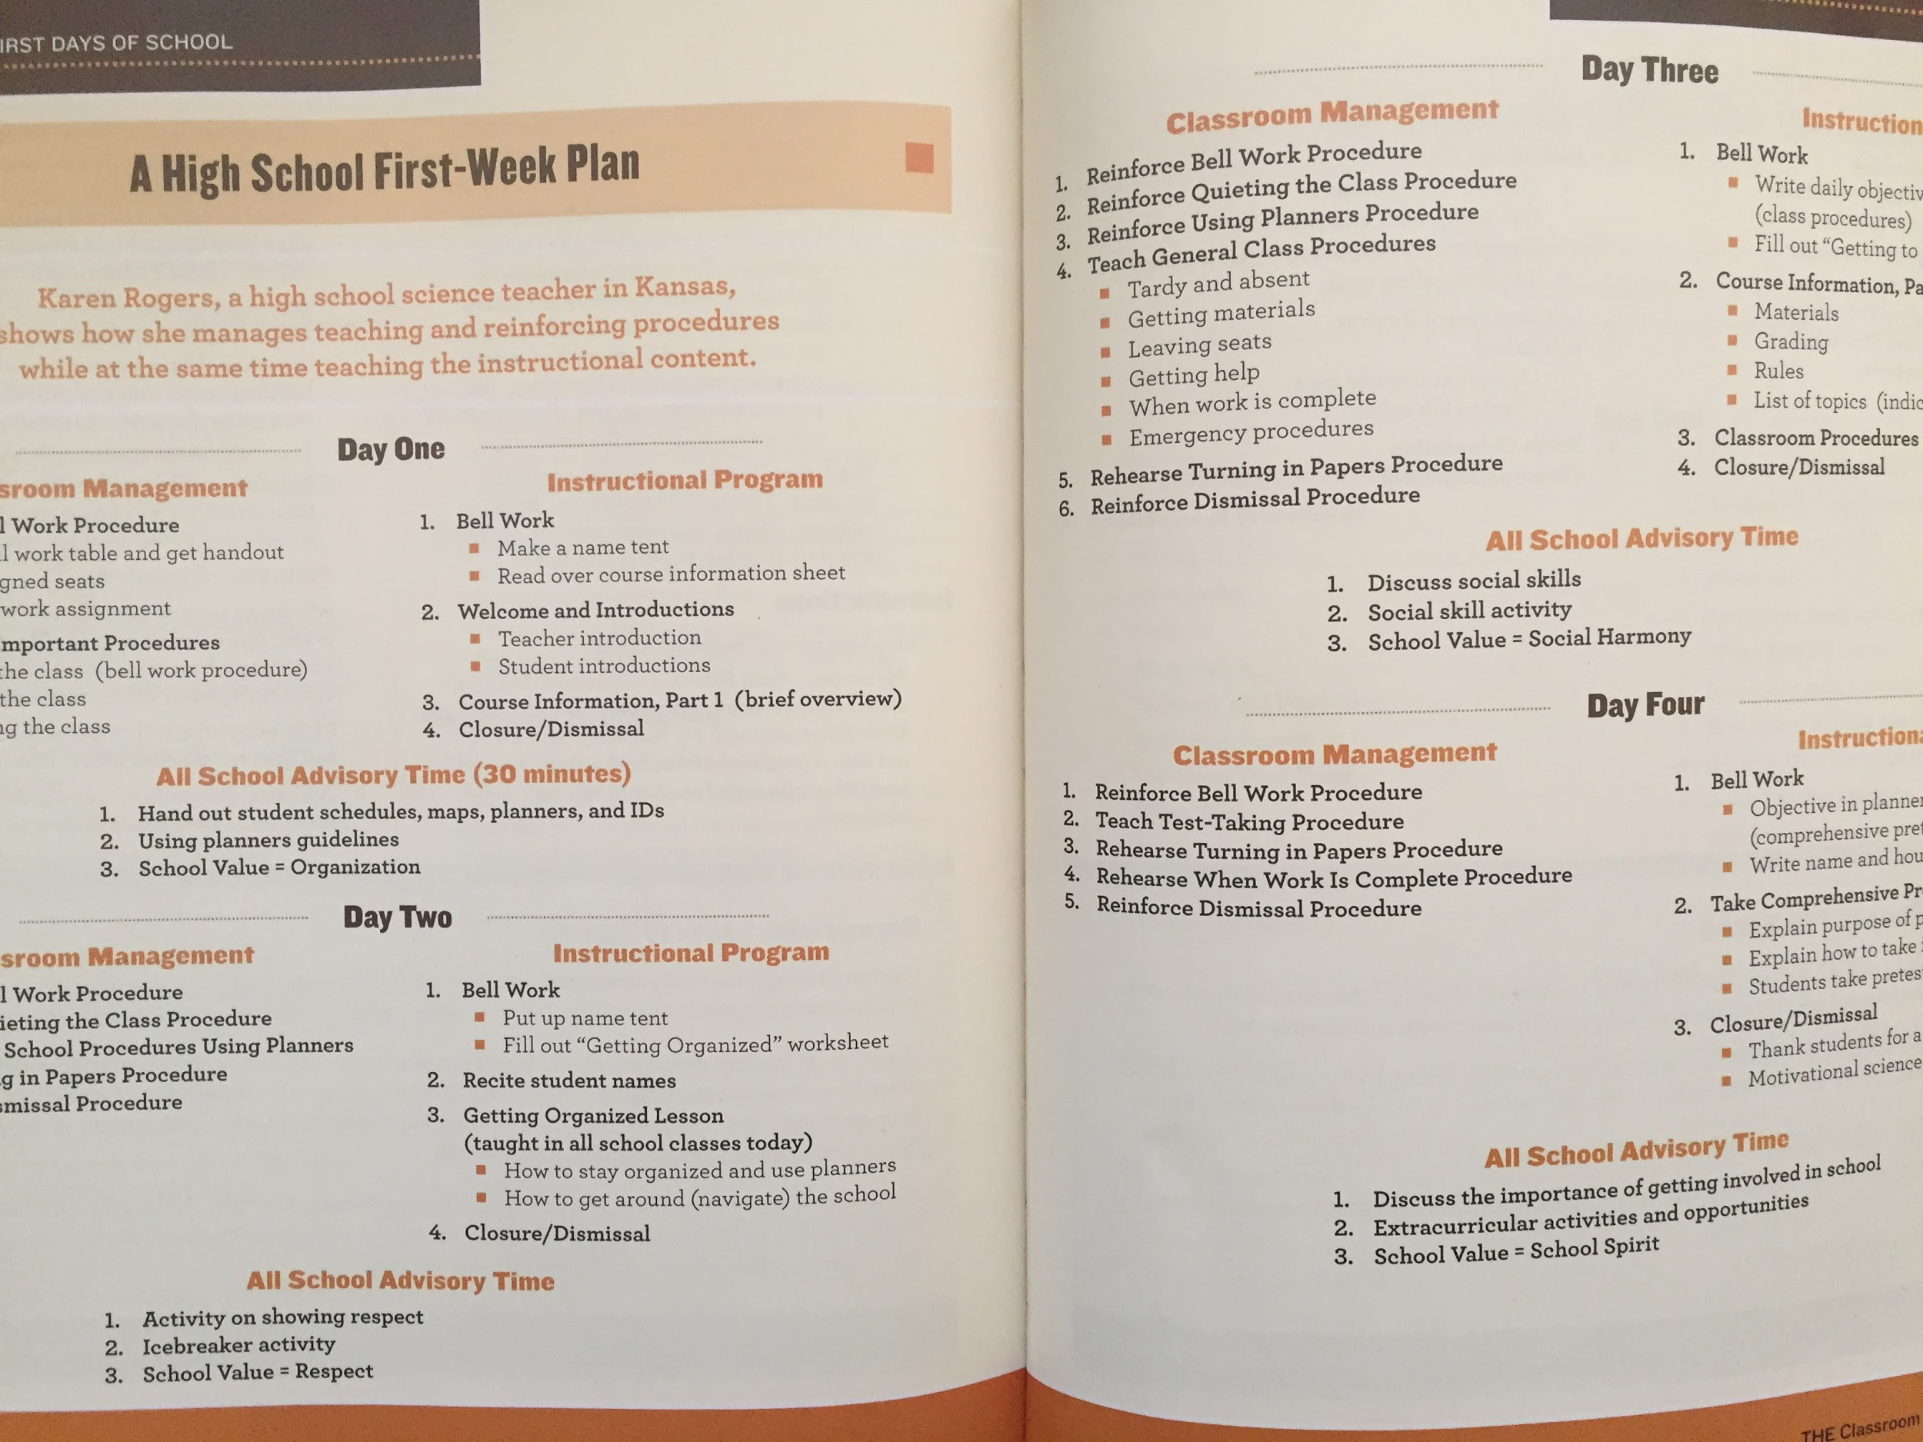
Appendix B
Personality Test: https://www.16personalities.com/personality-types
Multiple Intelligence Test: http://www.edutopia.org/multiple-intelligences-assessment

Appendix C

