World Literature
Middle Eastern Literature
The Kite Runner Unit Plan
The Early Years in Kabul
11th Grade AP English
Driving Question: What does Human Dignity look like?
Standards
RL.11-12.
Read closely to comprehend texts of grade-level appropriate complexity
- Determine what the text says explicitly and implicitly.
- Identify and analyze any ambiguities in the text.
- Provide an objective summary of the text.
- Cite strong and thorough textual evidence.
RL.11-12.2
Determine and analyze themes and/or central ideas of texts:
- Determine themes and/or central ideas.
- Analyze in detail the development of the themes and/or central ideas over the course of the text, including how they interact and build on one another to produce a complex account.
- Cite strong and thorough textual evidence.
RL.11-12.5
Analyze how an author’s choices about structuring and relating different elements in the text (e.g., use of epilogues, prologues, acts, scenes, chapters, stanzas) contribute to meaning as well as aesthetic impact.
W. 11-12. 4
Produce clear and coherent writing in which the development, organization, style, and format (e.g., MLA, APA) are appropriate to a range of tasks, purposes, and audiences. (Grade-specific expectations for writing types are defined in standards 1–3.)
W 11-12. 7
Conduct short as well as more sustained research projects to answer complex questions (including self-generated questions) or solve problems.
- Develop a complex research question or set of questions.
- Narrow or broaden the inquiry when appropriate.
- Synthesize multiple sources on the subject, demonstrating understanding of the subject under investigation.
SL.11-12.1
Initiate and participate effectively in a range of collaborative discussions (one on-one, in groups, and teacher-led) with diverse partners on grades 11–12 topics, texts, and issues, building on others’ ideas and expressing their own clearly and persuasively.
- Come to discussions prepared, having read and researched material under study;explicitly draw on that preparation by referring to evidence from texts and other research on the topic or issue to stimulate a thoughtful, well-reasoned exchange of ideas.
- Work with peers to promote civil, democratic discussions and decision-making, set clear goals and deadlines, and establish individual roles as needed.
- Propel conversations by posing and responding to questions that probe reasoning and evidence; ensure a hearing for a full range of positions on a topic or issue; clarify, verify, or challenge ideas and conclusions; and promote divergent and creative perspectives.
- Respond thoughtfully to diverse perspectives; synthesize comments, claims, and evidence made on all sides of an issue; resolve contradictions when possible; and determine what additional information or research is required to deepen the investigation or complete the task.

Learning Activities
The Learner will be able to analyze the first half of the book through a rhetorical lens, primarily when it comes to culture theories and post-colonialism
The Learner will be able to understand the historical background to the text
The Learner will be put in groups at the beginning of the novel and be assigned a theme in which they will research over the course of reading this novel. At the end, they will present their theme in a creative medium of their choice, with approval of the teacher, and present their findings.

Themes for the Final Project
Students will research a human rights issue (i.e. genocide, world hunger, domestic violence, terrorism, religious persecution) and produce a persuasive media product appropriate for a certain age group. Students will create a media product in which they persuade citizens to become aware of and to become involved in happenings around the world and their community. These themes will be researched in groups throughout our reading of The Kite Runner. We will have multiple class periods to work on this project, as well as anytime class instruction ends early. At the end of the novel, we will have a week to finish up our findings before presenting. Students will use scholarly sources and present their theme in their groups in the creative medium of their choice which needs to be approved by me. Since most of the themes don’t come to fruition until the end of the novel, we will plan time to finish up accordingly. This fits into the greater theme of the Semester surrounding human dignity. Presentations should be anywhere between 15-20 minutes.
I will ask students to number off their top 3 themes at the beginning of teaching this project. Then, I will put them in groups based on 1)their interests and 2)the people that will be in the groups.
Students will research a human rights issue (i.e. genocide, world hunger, domestic violence, terrorism, religious persecution) and produce a persuasive media product appropriate for a certain age group. Students will create a media product in which they persuade citizens to become aware of and to become involved in happenings around the world and their community.

Narrative Plot Structure:
- Setting
- Historical Background
- Conflit(s)
- Exposition
- Climax
- Falling Action
- Resolution
- Non-Chronological Order
- Foreshadowing
Character perspective
- Protagonist
- Antagonist
- Narrator
- Is the narrator the protagonist?

The Kite Runner
Day One
Why should we read this book?
Standards
RL.11-12.2
Determine and analyze themes and/or central ideas of texts:
- Determine themes and/or central ideas.
- Analyze in detail the development of the themes and/or central ideas over the course of the text, including how they interact and build on one another to produce a complex account.
- Cite strong and thorough textual evidence.
Objectives
The learner will be able to understand the historical background to the text
The learner will be able to understand why this is an important novel to read
https://docs.google.com/presentation/d/1nl27jkSKgCftQZEXAgcw5jumMRkUtSWXP-bzLWkDBRA/edit?usp=sharing

Learning Activities
- Before starting the book as a class, we will first learn why this book is a part of the 11th grade curriculum.
- Begin with reflection. Full reflection link :
  - https://docs.google.com/document/d/1MMkvE09baPP6OxgFqUyPgHHISAYZ_JeFMvZGDwlvcjM/edit?usp=sharing
- Give each student a notecard and ask them to write down 1-2 things they know about Afghanistan, the Taliban, or about the Middle East in general. Allow 2-3 minutes for students to write and think.
- Next, pull up the polleverywhere and ask students to submit at least on of their answers from their notecard.
  - https://www.polleverywhere.com/free_text_polls/35NlcMB86zb0KdK
  - Through these answers, we are able to understand determine that it is important to learn about these things!
- Transition into Afghanistan in the 1800s, 1900s, and Soviet Rule in Afghanistan.
- If there is time, go over these two sites in groups.
  - Interactive map of US foreign relations with Afghanistan since 9/11 http://www.nytimes.com/interactive/2011/06/22/world/asia/afghanistan-war-timeline.html
  - 4:31-7:50 https://www.youtube.com/watch?v=nlsnnhn3VWE until the end of the Afghanistan discussion
  - Afghanistan then and now https://www.youtube.com/watch?v=mpy2rzMVQBQ
- Review chapter one. Use the rhetorical devices in google slides to guide the discussion of chapter one.
- Write one thing on the notecard that they learned.
- Use remaining time to start the book
- Ask students to read the first three chapters for the next class.
Assessment
- Notecards to assess the background knowledge on Afghanistan
- Have them fill out on the back of the notecard either a) one thing they learned or b)one way in which their opinion of Afghan culture changed
Reflection
When I teach this again, I want to be able to have students move around more often. This means some more pair and shares and find other creative ways to have students move around more often. Also, do rhetorical devices before the video or the interactive map.

The Kite Runner
Day Two
Chapters 1-3
Standards
RL.11-12.
Read closely to comprehend texts of grade-level appropriate complexity
- Determine what the text says explicitly and implicitly.
- Identify and analyze any ambiguities in the text.
- Provide an objective summary of the text.
- Cite strong and thorough textual evidence.
RL.11-12.2
Determine and analyze themes and/or central ideas of texts:
- Determine themes and/or central ideas.
- Analyze in detail the development of the themes and/or central ideas over the course of the text, including how they interact and build on one another to produce a complex account.
- Cite strong and thorough textual evidence.
RL.11-12.5
Analyze how an author’s choices about structuring and relating different elements in the text (e.g., use of epilogues, prologues, acts, scenes, chapters, stanzas) contribute to meaning as well as aesthetic impact.
Objectives
The learner will be able to analyze the first three chapters and be able to identify the main characters, the setting, and the overall importance of these chapters in the development of the book.
The learner will be able to analyze the effect that the timeline and flashbacks has on the story.
Learning Activities
- Pass out class activity. Have students begin to fill out character charts that will identify all of the characters and their struggles. Do this in small groups for collaboration.
- Group up and have students discuss the importance of the novel “beginning at the end.” Have them share their answers with the class, making sure that they are focusing on rhetorical strategies and the idea of creating suspense.
  - Is the author successful?
  - Does it make you want to continue reading?
  - How does the brief nature of the first chapter affect you as a reader? (We should have gone over these questions on day 1).
- Once they have addressed these questions, have the students further analyze the book, beginning with the next chapter. Fill out the character chart for Hassan, Baba, Ali, and Sanaubar.
- Have students group up and ask groups to write down characteristics of either a) Amir’s relationship with Baba (Chapter 3) or b) Amir’s relationship with Hassan (Chapter 2). Have students use evidence from the book as a way to cite themselves. Assign a scribe and a speaker for each group and have them write down moments in the book that indicate any type of relationship between Amir and either Hassan or Baba.
- Have students share what they found.
Assessment
- Have the groups turn in their group activity to assess..
  - Their understanding of the book and the characters
  - Their ability to find information from the text and use it to prove their position.

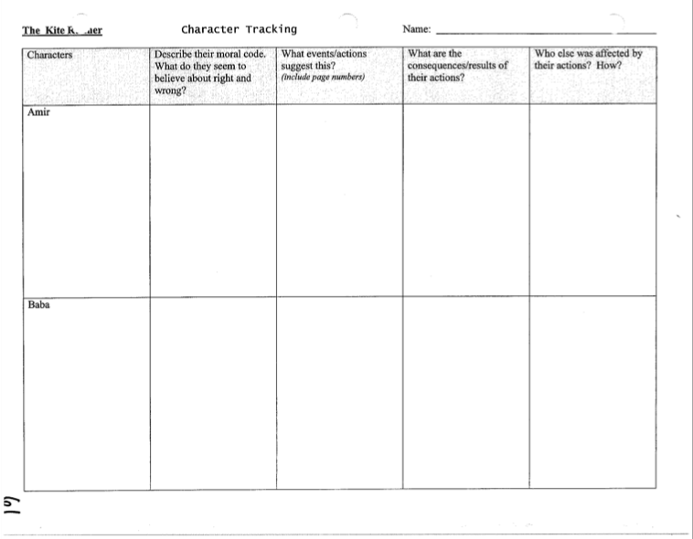

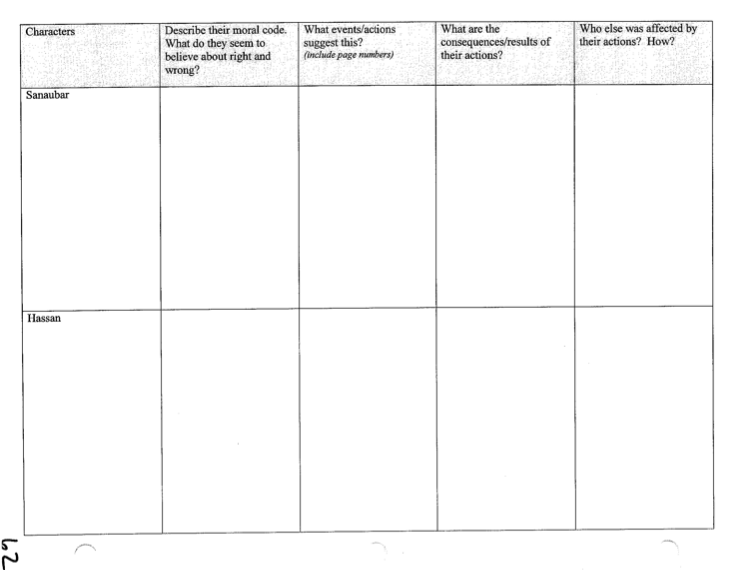
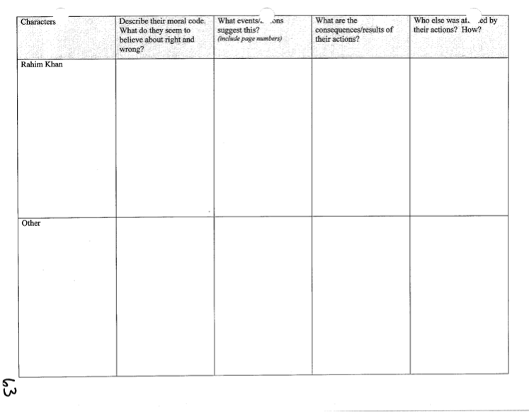
The Kite Runner
Day Three
Chapters 4-5
Standards
RL.11-12.5
Analyze how an author’s choices about structuring and relating different elements in the text (e.g., use of epilogues, prologues, acts, scenes, chapters, stanzas) contribute to meaning as well as aesthetic impact.
Objectives
The learner will be able to summarize the events of these chapters.
The learner will be able to assess the relationships between the two characters.
The learner will be able to identify rhetorical strategies such as irony through the events of these chapters.
Learning Activities
- Have students fill out their character charts. In chapter 5, we learn a lot about Assef and this is all important for the following chapters. Allow students to fill out these charts in small groups, while also providing them discussion questions on a worksheet about the chapter. There is a lot that happens in these chapters and I think that it is best if they are able to discuss these things in small more intimate groups. (Discussion questions attached on the following page).
- Bring the discussion questions back to the whole class. Have students share their answers and their reasonings behind their answers. This allows for students to slowly summarize the events of the chapter while also identifying the relationships between the main characters.
- Teach the concept of irony and ask the students to identify some of these moments in chapter 4.
  - https://docs.google.com/presentation/d/1SOz9_M120KBOL2LeTb8zPEKBA3uyiVSBUIJblD_Gn5Y/edit?usp=sharing
- Teach the idea of foreshadowing and go through chapter 5, identifying how we as readers can be prepared for what is happening next. (This is probably the best time to talk to the students about the more grim and sad moments of this novel that are to come).
- Have students fill out an exit slip. What gives someone dignity?
Assessment
Have students turn in their discussion questions for participation credit and to evaluate if their thinking is growing deeper than surface level.

Discussion Questions for Chapters 4 and 5

- Is Amir a good friend to Hassan? Is Hassan a good friend to Amir?

- What are your thoughts about Hassan and Baba’s relationship? What does Amir think of their relationship?

- Discuss the encounter between Assef and Amir/Hassan. What are some of the tensions between these boys?

The Kite Runner
Day 4
Project based learning project work day
Standards: W 11-12. 7
Conduct short as well as more sustained research projects to answer complex questions (including self-generated questions) or solve problems.
- Develop a complex research question or set of questions.
- Narrow or broaden the inquiry when appropriate.
- Synthesize multiple sources on the subject, demonstrating understanding of the subject under investigation.
Objectives:
Students will research a human rights issue (i.e. genocide, world hunger, domestic violence, terrorism, religious persecution) and produce a persuasive media product appropriate for a certain age group. Students will create a media product in which they persuade citizens to become aware of and to become involved in happenings around the world and their community.
Learning Activities:
- Today, we will be working on credible resources for our project for the year. Students will group up and discuss their topic (genocide, world hunger, domestic violence, terrorism, religious persecution). Students should have already been put into groups at the beginning of the unit. When they’re done with their group work, we will discuss credible resources.
PowerPoint
○ Instructions about how to log onto the library website
○ Step-by-step direction on how to access peer reviewed journals and articles
○ Information about how to save/print/cite those articles
○ Details about the differences between primary, secondary, and tertiary sources and the instances in which they are acceptable to be used in an academic paper
○ What makes a non-academic work reliable?
○ Give instructions on how to complete an annotated bibliography
Guided Discovery
○ Allow students to grab laptops from the cart and log onto the library website and access the academic articles
○ Ask them to search for articles that pertain to their primary source
○ Go around and address every student’s questions and concerns while the other students are working individually
Collaborative Work
○ Give students time to talk in small groups about the articles they have found and the ideas that they have for their research
Assessment:
The students will take notes during the Powerpoint presentation
The students will create an annotated bibliography using (2) of the sources that they found while researching
Teacher observation and questioning will be used to make sure that the students know the importance and the basics of how to research for an academic paper.

The Kite Runner
Day 5
Chapter 6
Standards
RL.11-12.
Read closely to comprehend texts of grade-level appropriate complexity
- Determine what the text says explicitly and implicitly.
- Identify and analyze any ambiguities in the text.
- Provide an objective summary of the text.
- Cite strong and thorough textual evidence.
RL.11-12.2
Determine and analyze themes and/or central ideas of texts:
- Determine themes and/or central ideas.
- Analyze in detail the development of the themes and/or central ideas over the course of the text, including how they interact and build on one another to produce a complex account.
- Cite strong and thorough textual evidence.
Objectives
The learner will be able to summarize the events of this chapter and determine why they are important.
The learner will be able to evaluate the importance of the relationship between the two characters.
Learning Activities
Kite Running Day!
- View photos attacked in the following page to show the beauty of kite running and understand the importance of kite running in the Afghan culture.
- Show these youtube videos about kite running: https://www.youtube.com/watch?v=sfeNUaKxufA
- https://www.youtube.com/watch?v=sl3qWHkqfI8
- Summarize the events of the chapter. What is Hassan’s role? What is Amir’s role? How are these roles indicators of both their relationships and of their status in Afghanistan?
- Kite Making activity - attached to the following pages. Have students do this in their research groups.
Assessment
If there is time, have groups present their kites to the class.

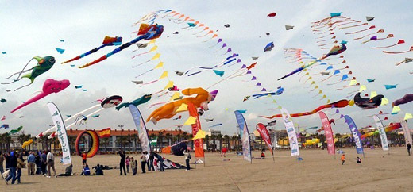
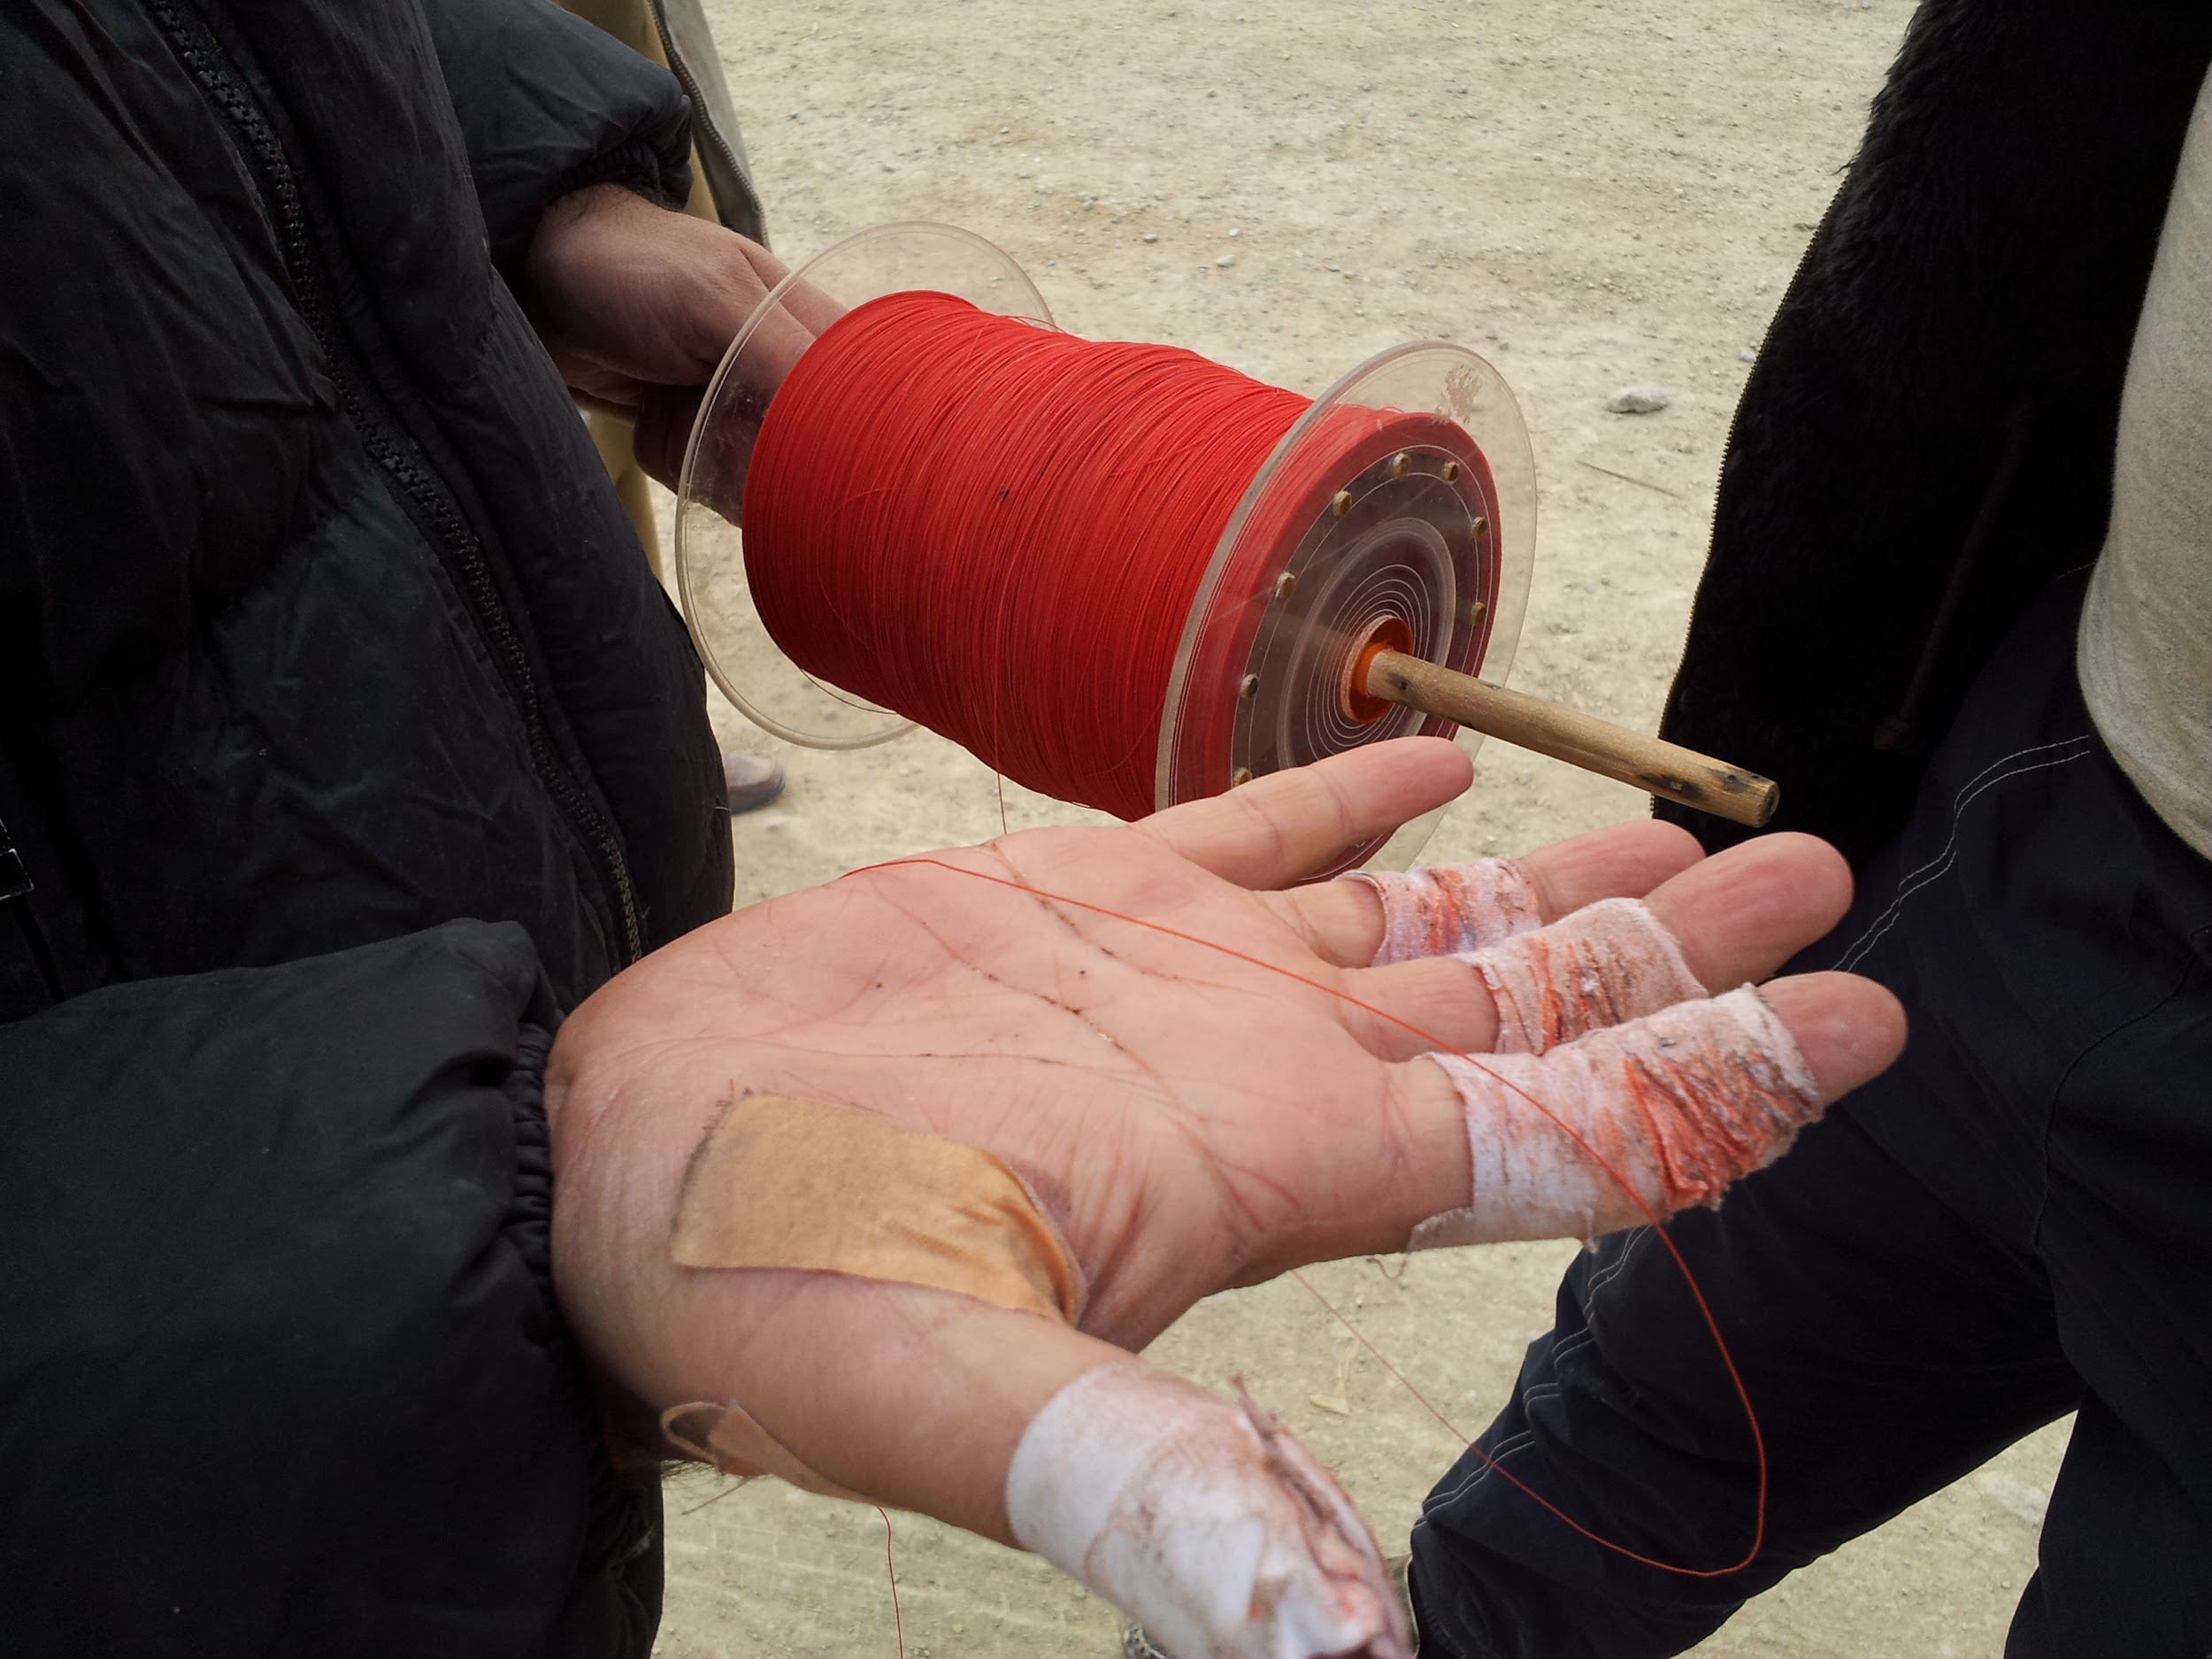
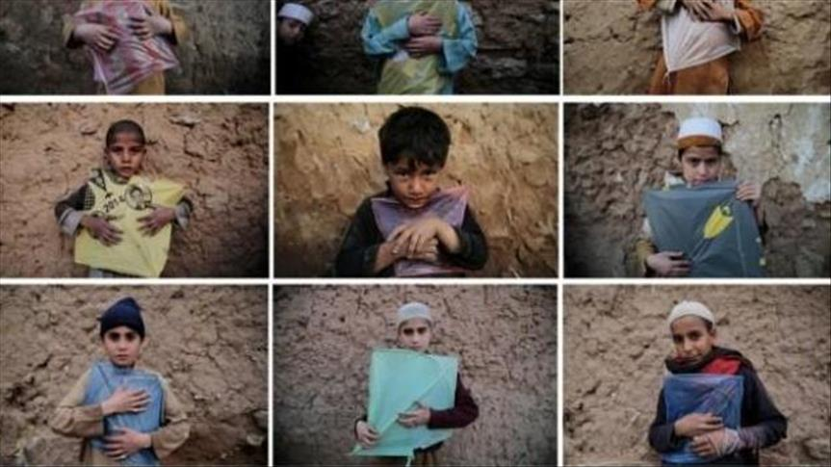
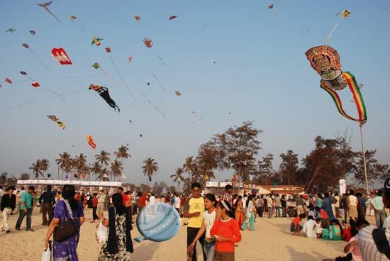

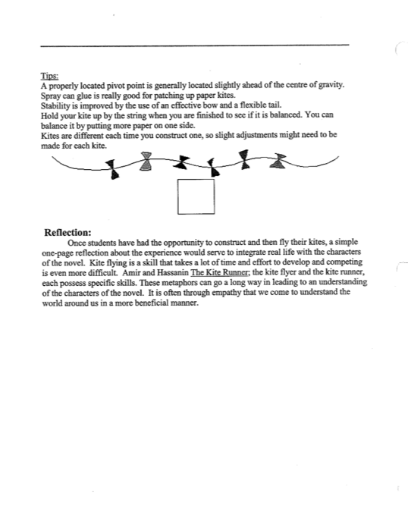
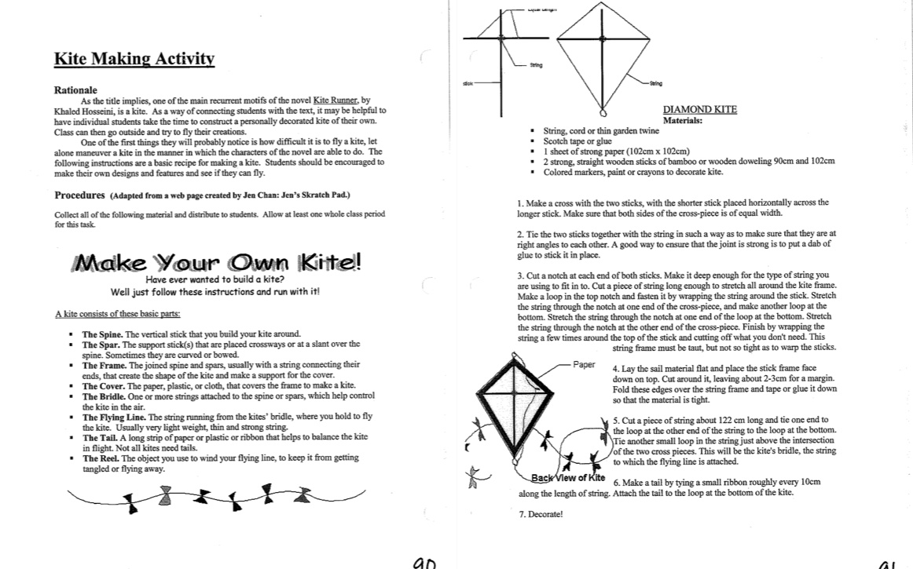

The Kite Runner
Day 6
Chapter 7-8
Standards
RL.11-12.
Read closely to comprehend texts of grade-level appropriate complexity
- Determine what the text says explicitly and implicitly.
- Identify and analyze any ambiguities in the text.
- Provide an objective summary of the text.
- Cite strong and thorough textual evidence.
RL.11-12.5
Analyze how an author’s choices about structuring and relating different elements in the text (e.g., use of epilogues, prologues, acts, scenes, chapters, stanzas) contribute to meaning as well as aesthetic impact.
Objectives
The learner will explain and summarize the events of these chapters
The learner will inspect characters motives behind what happens in this chapter
The learner will explain the importance of how the author designs the timelines of these two chapters
Learning Activities
- Since this chapter is pretty grim and is really hard to understand and identify with, I think this would be the best time to explain the difference between the Pashtuns and the Hazaras.
- Bring the discussion back to the entire class to help students understand the motivations in this chapter. What is the significance of Hassan running and winning the final kite? Why does Assef feel entitled to believe that it belongs to him? Why doesn’t Amir do anything?
- Further discuss why Amir treats Hassan differently in chapter 8. I think that these chapters can be really tough on students and I fear that pushing them too far in the “analyzing” this. I also think really good discussion can come from these chapters but it should be student led.
- Group students up and ask them to do some research on their computers about the Pashtun and Hazara conflict in Afghanistan. Guide the students by visiting the groups and help them further understand this conflict as they are researching. Students can do research on this for the rest of class in their groups if there is time. This will help them with quizzes and tests as well as with their final project.
Assessment
No formal assessment. I can just determine their progress by checking in with each student while they are working.

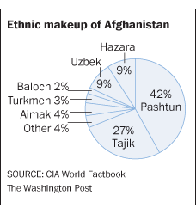

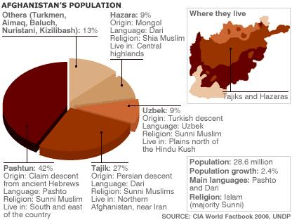
The Kite Runner
Day 7
Chapters 9 and 10
Standards
RL.11-12.5
Analyze how an author’s choices about structuring and relating different elements in the text (e.g., use of epilogues, prologues, acts, scenes, chapters, stanzas) contribute to meaning as well as aesthetic impact.
RL.11-12.1
Cite strong and thorough textual evidence to support analysis of what the text says explicitly as well as inferences drawn from the text, including determining where the text leaves matters uncertain.
Objectives
Learner will summarize the final events that Baba and Amir experience in Kabul.
Learners will observe and identify the rhetorical strategies that signify the mood of the events that are happening.
Learners will evaluate the relationships of the characters at this point in the novel.
Learning Activities
- Since this section of the chapter is coming to a close, students will prepare for a reading quiz that tests their knowledge thus far. We will begin class by going over the character chart and filling in any areas that are missing or that need to be addressed. Students can use this time to work on their own or with groups as they complete all of the paperwork that has been assigned.
- As a class, we will summarize all the events that have taken place - especially the events in chapters 9 and 10.
- Deeper thinking: I will ask the students to focus on the character’s relationships with each other: how have they changed since the beginning of the novel.
- Deeper thinking: How does the cultural divide between the Pashtuns and the Hazaras play a role in this book?
- If there are few questions about chapters 9 and 10, students can use the remaining time to study with each other for the test on chapters 1-10.

The Kite Runner
Day 8
Chapters 1-10 Test

RL.11-12.1
Cite strong and thorough textual evidence to support analysis of what the text says explicitly as well as inferences drawn from the text, including determining where the text leaves matters uncertain.
RL.11-12.2
Determine two or more themes or central ideas of a text and analyze their development over the course of the text, including how they interact and build on one another to produce a complex account; provide an objective summary of the text.
RL.11-12.5
Analyze how an author's choices concerning how to structure specific parts of a text (e.g., the choice of where to begin or end a story, the choice to provide a comedic or tragic resolution) contribute to its overall structure and meaning as well as its aesthetic impact.
R.L. 11-12. 6.
Determine an author’s point of view or purpose in a text in which the rhetoric is particularly effective, analyzing how style and content contribute to the power, persuasiveness, or beauty of the text.
Objectives
The learner will be able to implement the skills learned from these standards.

Learning Activities
- Take test
- Silent reading time and student groups can go into the hallway to work if they are all finished in order for the class to stay silent.

The Kite Runner Name________________________
Chapters 1-10 Test
Miss Barnes

Directions: Match the following descriptions to the character that it best fits.

- ______ Assef a. The father of Hassan

- ______ Amir b. The father of Amir

- ______ Baba c. Neighborhood bully

- ______ Hassan d. The kite flyer

- ______ Sanaubar e. Baba’s most loyal friend

- ______ Ali f. Did not want a son with a cleft lip

- _______ Rahim Khan g. The Kite Runner

Directions: Fill out each question thoroughly.
- What did Amir and Hassan’s relationship look like at the beginning of the book? What is it like by the end of chapter 10? What has caused these changes? Can anyone be blamed?

- Using the information that you about the Pashtuns and Hazaras, explain in detail the cultural problems between the Pashtuns and Hazaras. Connect these problems with The Kite Runner. How do these difference affect the characters in the novel?

- What is the significance of Kite Flying in Afghanistan? (Hint: Think back to the videos). How does the importance of kite flying and running affect the characters in the novel? (Baba, Amir, Hassan, and Assef, especially).

The Kite Runner
Day 9
Project Based Learning Research Day

Standards: Conduct short as well as more sustained research projects to answer complex questions (including self-generated questions) or solve problems.
- Develop a complex research question or set of questions.
- Narrow or broaden the inquiry when appropriate.
- Synthesize multiple sources on the subject, demonstrating understanding of the subject under investigation.
Objectives:
The learner will develop questions to spark their research
The learner will discuss the novel as it applies to their topic.
The learner will develop a main question in which to branch their research off of.
Learning Activities
- Students will do an formative assessment about credible research to ensure that they’ve retained the information from the former class period. This will be in the form of the quiz on the google classroom page.
- Students will gather in their assigned groups and begin to do research on their own for the first half of class.
- In the middle of class, I will interrupt their research to have a quick discussion.
  - How are we going to explore human dignity with our topics.
  - I will show a few different graphic organizers and then ask groups to create one about their topic.
  - http://www.inspiration.com/visual-learning/graphic-organizers
  - https://www.eduplace.com/graphicorganizer/
  - http://www.educationoasis.com/printables/graphic-organizers/
    - Here are some sites for organizers. They can either be printed and given to students or the links can be put on google classroom and the students can explore how to best use them.
- For the last half of class, groups will work together to create a graphic organizer around their research question(s). I will go around the room and assist in this.
- For the assessment, I will have the groups turn in their graphic organizer.

The Kite Runner
Day 10
Project Based Learning Research Day
Standards:
W. 11-12. 4
Produce clear and coherent writing in which the development, organization, style, and format (e.g., MLA, APA) are appropriate to a range of tasks, purposes, and audiences. (Grade-specific expectations for writing types are defined in standards 1–3.)
W 11-12. 7
Conduct short as well as more sustained research projects to answer complex questions (including self-generated questions) or solve problems.
- Develop a complex research question or set of questions.
- Narrow or broaden the inquiry when appropriate.
- Synthesize multiple sources on the subject, demonstrating understanding of the subject under investigation.
SL.11-12.1
Initiate and participate effectively in a range of collaborative discussions (one on-one, in groups, and teacher-led) with diverse partners on grades 11–12 topics, texts, and issues, building on others’ ideas and expressing their own clearly and persuasively.
- Come to discussions prepared, having read and researched material under study;explicitly draw on that preparation by referring to evidence from texts and other research on the topic or issue to stimulate a thoughtful, well-reasoned exchange of ideas.
- Work with peers to promote civil, democratic discussions and decision-making, set clear goals and deadlines, and establish individual roles as needed.
- Propel conversations by posing and responding to questions that probe reasoning and evidence; ensure a hearing for a full range of positions on a topic or issue; clarify, verify, or challenge ideas and conclusions; and promote divergent and creative perspectives.
- Respond thoughtfully to diverse perspectives; synthesize comments, claims, and evidence made on all sides of an issue; resolve contradictions when possible; and determine what additional information or research is required to deepen the investigation or complete the task.
Objectives:
The learner will apply concepts from the novel to their topic.
The learner will generate a thesis and begin to create an outline.
The learner will decide how to best present their project.
Learning Activities:
- On our last day of research before returning to the novel, students will begin to shape their research project. After a brief overview of our goals for the day, I will allow students to begin working on their project. On a shared google doc, students will begin to type everything that they’ve researched on their own from the previous class period.
- Have students take the survey. (next page)
- Close the class in a lecture about human dignity that fits in with the survey. These tough questions are ones that are addressed in The Kite Runner.

WHAT WOULD YOU DO?

DIRECTIONS: Read each of the following questions. Respond HONESTLY on your own paper. Do not discuss anything with your neighbors yet.

1. What would you do if you saw someone steal the answers to a test?
2. What would you do if you saw someone damage a textbook?
3. What would you do if you saw someone writing on the bathroom walls?
4. What would you do if you saw someone spit snuff in the water fountain?
5. What would you do if you saw someone in the teacher’s desk without permission?
6. What would you do if you heard a racist joke?
7. What would you do if you heard someone call someone else a racist name?
8. What would you do if you received a racist e-mail?
9. What would you do if you heard someone say, “That’s gay”?
10. What would you do if you heard a sexist joke?
11. What would you do if you saw someone bullying someone?
12. What would you do if you saw a fight at school?
13. What would you do if you saw a fight in public?
14. What would you do if you saw a salesperson be rude to someone of a different nationality or race?
15. What would you do if you saw someone steal an elderly lady’s purse?
16. What would you do if you witnessed a hit and run?
17. What would you do if you saw someone shoplifting?
18. What would you do if you were in a grocery store and saw an adult slap a toddler in the face?
19. What would you do if you saw someone damage a neighbor’s mailbox?
20. What would you do if you saw a dog left in a hot car?
21. What would you do if you saw a baby left alone in a hot car?
22. What would you do if you heard someone verbally abusing another person?
23. What would you do if you saw someone verbally or physically abusing another person?
24. What would you do if you saw someone put drugs into someone’s drink?
25. What would you do if you saw someone sexually abusing someone?

